***Lab#8***

Task#1

Write a C++ program which initializes an array of 10 numbers and finds the highest and lowest number in the array.

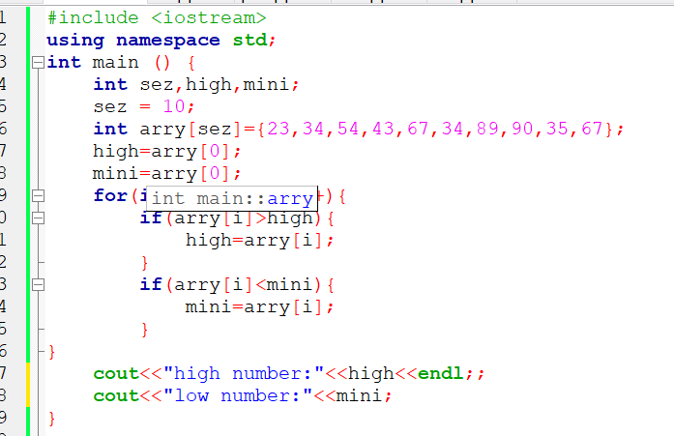

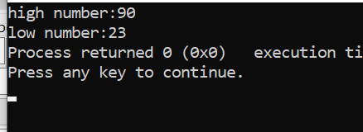

Task#2

Write a C++ program which takes input of 5 employees with their id and their salaries. Print it in a table format.

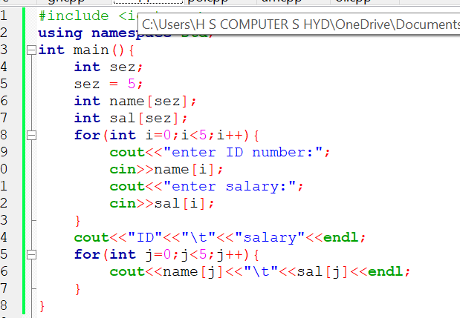

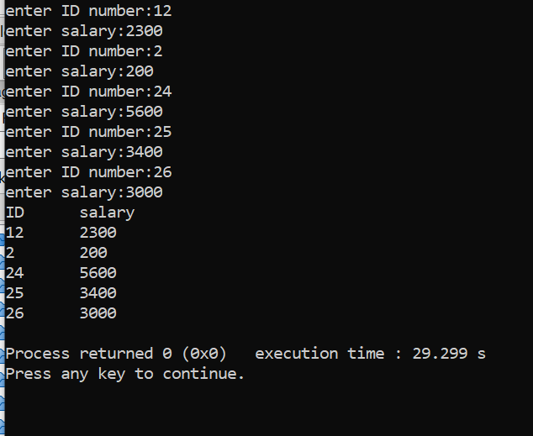

Task#3

Take 20 integer inputs from user and print the following:

number of positive numbers

number of negative numbers

number of odd numbers

number of even numbers

number of 0.

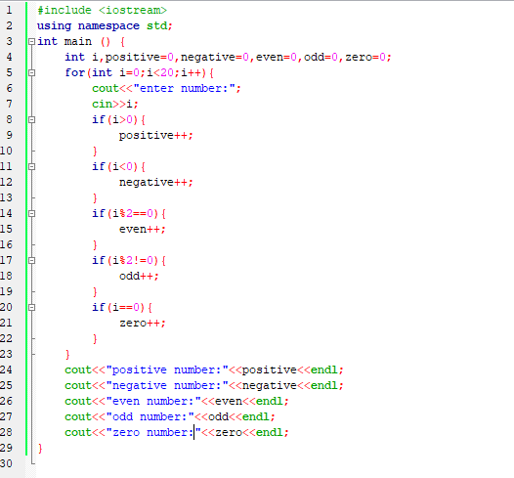

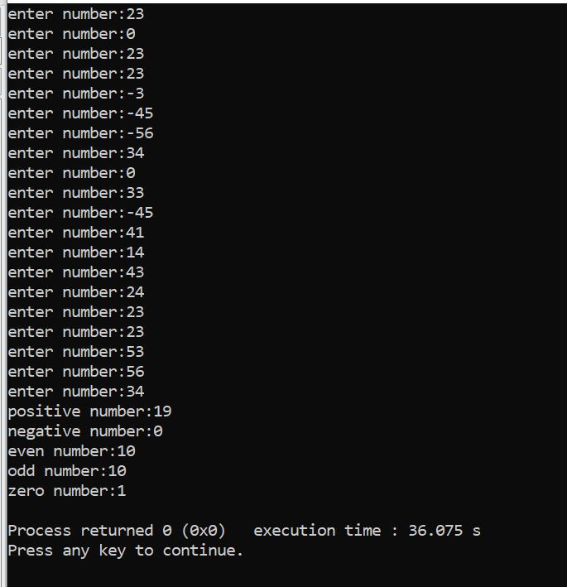

Task#4

Take an array of 10 elements. Split it into middle and store the elements in two different

arrays. E.g.-

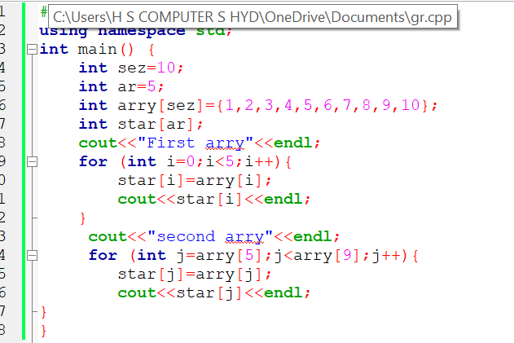

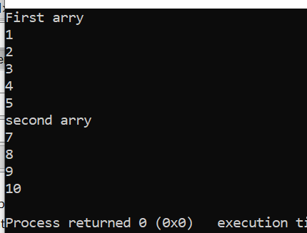

Task#5

Create a record for five students i.e. their roll#, semester and section. Print in a proper format.

